AS Business Studies
Induction Task
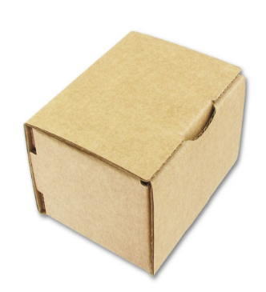
The Box

You have been given this cardboard box.
How are you going to turn it into a profitable product?

Your task is to turn this box into a product that will make a profit. You can do anything to it: redesign the packaging, put things inside it and so on. The box itself costs 8p.

You must:
- Draw a design of your product (this can either be by hand or on the computer)
- Write a brief business plan (a minimum of two pages) including:
  - An outline of what your product is and why you chose it;
  - The finances you will need to set up your business. This should include estimate costs, selling prices and forecast sales/profit;
  - The market you are entering including an outline of your customer and your competition.
- Create an accompanying PowerPoint outlining your plans that you will be prepared to present on the first day. You will present your product design the outline of your product and your market to your teachers.

Get your thinking caps on and good luck!
Some ideas that you cannot steal!
